- MARKETS
- HEARD ON THE STREET

Salesforce Can Bid Aloha to Big Deals

With activists circling, Marc Benioff has little choice but to keep focusing on margin improvement
Marc Benioff co-founded Salesforce and has run it for more than two decades.
By Dan Gallagher Updated Jan. 28, 2023 5:29 pm ET

Much is uncertain at Salesforce these days, save for this: The days of the company chasing major M&A deals are over for a long while.

The cloud software pioneer is experiencing the most significant slowdown in its history and has thus drawn the attention of activist investors. The latest is Elliott Management, which confirmed a major stake in the company earlier this week. It is already preparing an alternative slate of directors for the company’s board, according to The Wall Street Journal.
Salesforce announced a fresh slate of its own on Friday, with three new directors to replace two who are stepping down. That followed reports the previous day that the company was considering new board members and that Elliott was also preparing its own slate. Salesforce shares rallied nearly 6% on Thursday but lost a fraction on Friday. The sequence of events strongly suggests Salesforce’s board shuffle won’t be enough to ward off Elliott—or the specter of a proxy battle. So what comes next?
There is no easy answer. Investors clearly want Salesforce to be more profitable. Starboard, another activist now in the stock, said as much when it released a slide deck late last year outlining its concern about the company’s “subpar mix of growth and profitability.” Salesforce seems to agree, having outlined a plan last year to boost its operating margins, effectively doubling down on that goal with its announcement earlier this month to lay off 10% of its workforce.
But growing profits is a lot easier when the top line is also moving upward, and that is far from a given as the slowing economy makes corporate tech managers pickier about their spending. Even industry titan Microsoft has warned of a notable slowdown ahead for its Azure cloud business this year. Wall Street, meanwhile, expects Salesforce’s billings growth to be in the single-digit percentage range for at least the next three quarters after averaging 22% over the last eight.
Boosting growth through another big deal seems off the table now. Salesforce has been a voracious buyer, having made 72 acquisitions since 2006, according to data from FactSet. The transactions got bigger as Salesforce did; the first megadeal was $2.3 billion paid for ExactTarget in 2013, and the latest was $27.7 billion for Slack in late 2020. But the pace has tried the patience of investors, giving weight to the idea that the company has been resorting to ever more expensive ways to buy growth. Salesforce shares have lagged behind the Nasdaq Composite Index by 26 percentage points since the announcement of the Slack deal and nearly 50 percentage points since the announcement of its $15.7 billion deal to buy Tableau Software in June 2019.
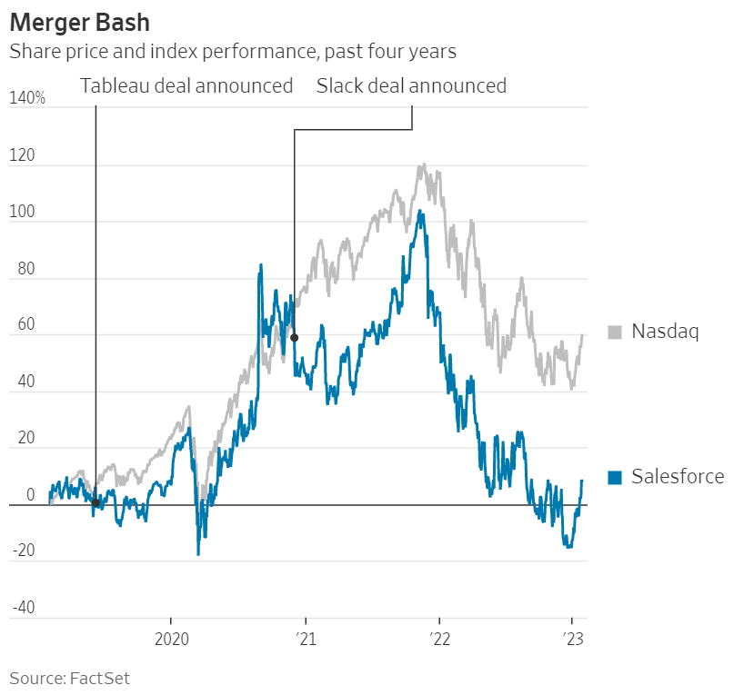

Unwinding some of those deals isn’t a likely option either. RBC Capital analyst Rishi Jaluria called Tableau “the underlying engine of Salesforce’s core enterprise-grade analytical functionality” in a note to clients earlier this week. And while Slack is more recent and seen as less aligned with Salesforce’s core offerings, divesting that business at anything other than a massive loss seems a stretch. Cloud stock valuations have reset significantly: The BVP Nasdaq Emerging Cloud Index is down 40% since the day the Slack deal was announced. “Overpaying is human, selling for scrap is…not what we advise,” wrote Sarah Hindlian-Bowler of Macquarie Capital.
Salesforce may still find a way to make peace with its activists. A proxy fight would be unfamiliar ground for Marc Benioff, a consummate salesman who co-founded the company and has run it for more than two decades. He is also the company’s sixth largest shareholder, according to FactSet, and a major landowner in Hawaii, which makes him fond of sprinkling the Hawaiian word for family liberally through the company’s calls and marketing materials. No family ever escapes drama.
Write to Dan Gallagher at dan.gallagher@wsj.com

