Review for Exam 1
- The exam consists of 25 multiple-choice questions (4 points each).The questions will cover material from chapters 2-5 of the textbook. The questions will be drawn approximately evenly (i.e. 6-7 questions) from each of the four chapters.
- This is a closed-book and closed-notes exam although I will provide a formula sheet. You should use pencil and calculator for the exam.

Chapter 2
Be able to identify which activity involves direct or indirect finance: indirect finance involves financial intermediaries
Distinguish three types of debt market (short-term vs long-term, intermediate-term)
Distinguish money market vs capital market
Understand the difference between over-the-counter and exchange trading (Most common stocks are traded over-the-counter, although the largest corporations have their shares traded at organized stock exchanges such as the New York Stock Exchange. Money market securities are usually more widely traded than longer-term securities and so tend to be more liquid)
Understand the difference between primary and secondary market: issuers acquire funds from primary markets
Understand the difference among foreign bond, Eurobond, Eurodollars, Eurocurrencies
Understand the three functions of financial intermediaries:
- Cost saving through economies of scale
- Risk sharing: increase its own risk and reduce the risks of its customers
- Alleviation of information asymmetry problem
- Adverse selection: ex ante; potential borrowers who are most likely to default are ones most likely to seek a loan
- Moral hazard: ex post; once a borrower gets the loan, he may shift to a more risky project.
Understand the three types of financial intermediaries and able to identify a financial institution belong to which type.
- Depository institutions
- Contractual savings institutions
- Investment intermediaries
Chapter 3
Understand the definition of interest rate (yield to maturity) and distinguish among interest rate, current yield, coupon rate, real interest rate
Distinguish among fixed payment loan, coupon bond and zero coupon bond
Be able to calculate the future value of an investment
Be able to calculate the present value (price) of a zero coupon bond
Be able to calculate the yield to maturity for a simple loan
Be able to calculate the present value (price) of a coupon bond
Be able to calculate the real interest rate based on the nominal interest rate (yield to maturity) and (expected) inflation rate
Be able to calculate the one year return on bond investment and distinguish between return and interest rate
Understand reinvestment risk: holding period longer than the term to maturity of a bond
Understand interest rate risk: bond price will change when interest rate changes. The longer the maturity of the bond, the higher the interest rate risk and the more volatile of the bond price and bond return.
Chapter 4
Be able to tell how the factors determine the demand of an asset ( a bond). Factors include: wealth, expected return, risk and liquidity
Be able to calculate expected return and the standard deviation of a bond
Understand what is demand curve: price and quantity demanded
Understand what is supply curve and what causes it to shift: investment opportunities, expected inflation rate, government activities (deficits)
Understand what is equilibrium, excess demand, excess supply and how the bond price will change with excess demand or excess supply
Be able to tell how the demand curve of a bond will shift when some economic fundamentals affect the factors: economic expansion, expected interest rate in the future, expected inflation rate, expected return on other asset markets (e.g. stock market), liquidity of stock market, (very important)
The Fisher effect, Business cycle effect (figure 4.4, 4.6 homework questions);

Chapter 5
Figure 5.1: the interest rates among 4 types of bonds
Understand what risk premium is and how it changes with the change of the factors: default risk, liquidity and income tax consideration (Very important)
Figure 5.2 : how change of corporate default risk shifts the demand curve for corporate bond and the demand curve for government bond (Very important)
Effect of subprime mortgage market collapse on the demand of corporate vs Treasury bonds and the risk premium
Effect of an increase of marginal tax rates on the demand for municipal bonds vs government bonds
The three facts of the yield curve
Expectation theory: Understand the meaning and the explanation for the yield curve facts ( what it can explain and what it fails to explain). Be able to calculate the interest rate with the formula
Market Segmentation theory: Understand the meaning and the explanation for the yield curve facts
Liquidity premium theory: Understand the meaning and the explanation for the yield curve facts
Implicit forward rate: Be able to calculate it with the formula.

Formula for Exam 1
Future value: FV=P*${(1+i)}^{n}$
Present value: $PV =\frac{CF}{ {(1+i)}^{n} }$
Coupon bond
$$P=\text{C}\text{*}\frac{1-{(1+i)}^{-n}}{i}+\frac{F}{\left(1+i\right)n}$$
$P_{c}=\frac{C}{i_{c}} i_{c}=\frac{C}{P_{c}}$
Current yield: i_{c} = C / P
one year discount bond, yield to maturity $i=\frac{F-P}{P}$
Inflation and interest rate: i =i_{r} + π^{e} i_{r} = i − π^{e}
Return:$R=\frac{C+P_{t+1}-P_{t}}{P_{t}} R=i_{c}+g$
Expected Return $\text{R}\text{e}\text{ = }\text{p}\text{1}\text{R}\text{1}\text{+}\text{p}\text{2}\text{R}\text{2}\text{+}…+\text{p}\text{n}\text{R}\text{n}$
Standard Deviation $σ=\sqrt{\text{p}\text{1}\text{(}\text{R}\text{1}\text{-}\text{R}\text{e}\text{)}\text{2}\text{+}\text{p}\text{2}\text{(}\text{R}\text{2}\text{-}\text{R}\text{e}\text{)}\text{2}\text{+}…+\text{p}\text{n}\text{(}\text{R}\text{n}\text{-}\text{R}\text{e}\text{)}\text{2} }$
Expectation Theory: 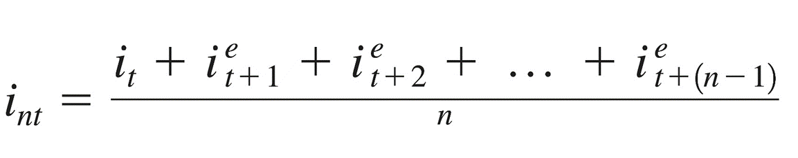
Implied Forward Rate:

