**CASE STUDY – STARTUP COMPANY VALUATION: FINTECH**

**The Company**: FinTech SaaS based start-up company that developed an innovative transaction platform that allows small businesses to manage with ease and security (using the facial recognition and other security verification software) on daily transactions between their vendors, customers, and banks.

**The Opportunity:** Estimated total subscription market opportunity of 10 million subscribers. Assuming initial market penetration of 0.10% (10,000 subscribers) growing to 400,000 (4.0% market penetration) by the 3rd year. These subscribers are willing to sign up and pay $4.0 per month. The ongoing cost of revenue is estimated at $2 per subscriber and operating expenses, including marketing, is estimated at $1 per subscriber.

**Revenue Growth and Ongoing Expense Assumptions:**

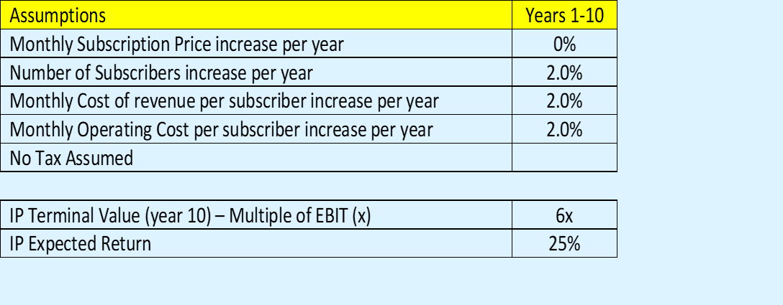

**IP Assumptions:** The present value of the development cost is initial estimated $10 per subscription (cost per customer acquisition). The firm has the IP patent to exploit for the next 10 years. The 10-year riskless rate is 3.0%, and the variance is 0.10 based on stock variance of similar SaaS Fintech companies’ stock price.