MIDTERM EXAM:
Section I: Basic & Advance Option Strategies (50)
Basic Option Strategies:
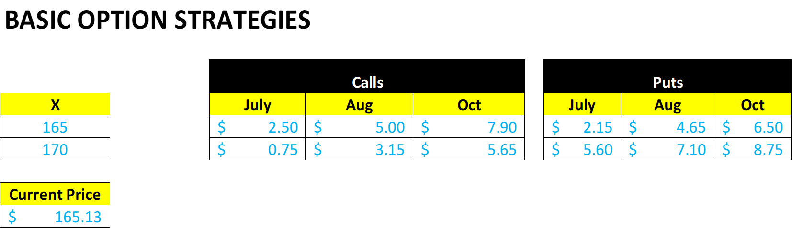
ACTION | TYPE | X | Premium | S | Payoff | Profit | BE | HPR%
BUY | July Call | 165 | 2.50 | 170 | 5 | 2.50 | 167.50 | 2.50/2.50=100%
BUY | Oct Str | 170 | 14.40 | 180 | 10 | (4.40) | 184.40/155.60 | -4.4/14.40=-30%
SELL | Aug Put | 165 | 4.65 | 145 | (20) | (15.35) | 161.35 | NA

Puts/Calls/Straddles both Buy and Sell
Advance Option Strategies:
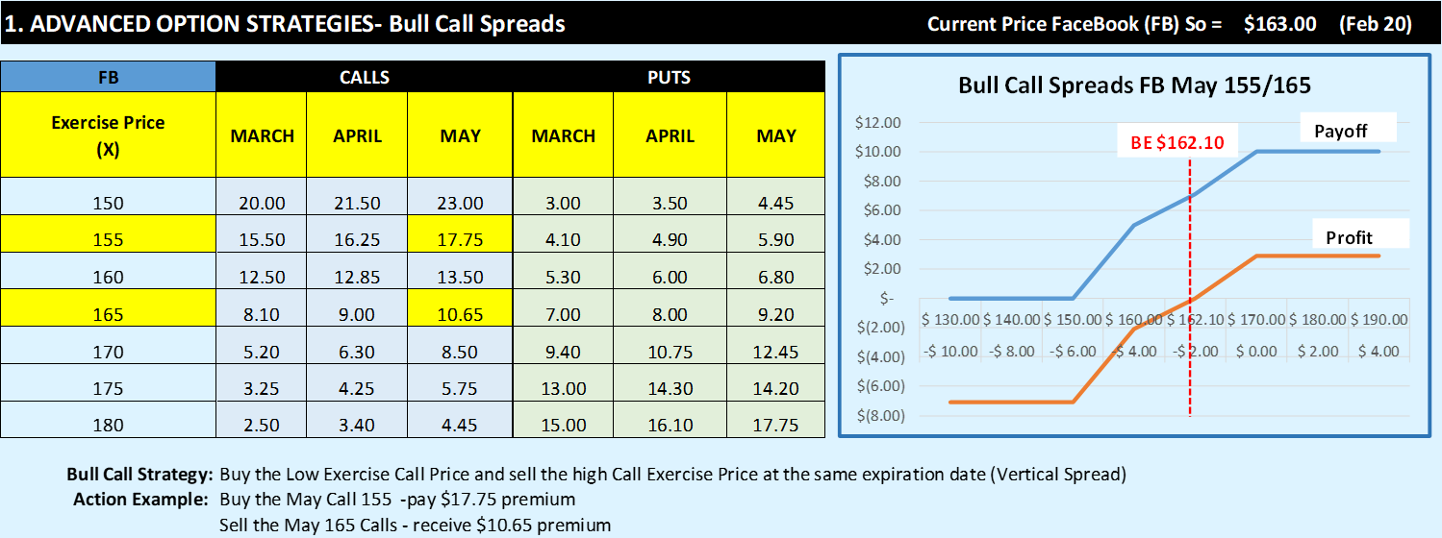
Bull Call Spreads/Bear Put Spreads/Bull Put Spreads/Bear Call Spreads/Butterflies
Action | Type | X | Net Premium | S | Payoff | Profit
Long | May Bull Call  (Buy Low/Sell High) | 155/165 | (7.10) | 170 | 10 | 2.90
Long | Apr Bear Put  (Buy High/Sell Low) | 150/180 | (12.60) | 140 | 30 | 17.40
Long | Mar Butterfly  (Buy High, Sell Avg, Sell Avg, Buy Low) | 155/175 | (2.55) | 165 | 10 | 7.45

Section II – Advising on Option Strategies (20)
Protective Puts
Covered Calls
Collars
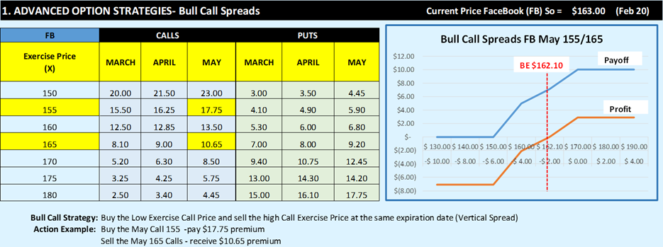
- You bought the 100 shares at $165 per share. You ask your broker to give you strategy to fully protect the stock at $165. What is the advice of the broker if you do not care paying for premium? To enter Protective Put

- What is your profit/Loss and HPR% if you sell the stock at 180?

Bought the stock 165 sold at 180 = $15 per share x 100 shares = $1,500
Payoff and Profit on the option = $0 and loss of 9.20 x 100 shares = (920)
Net Profit = $580
HPR% = Profit/ Investment = 580 / (16500+920) = 580 / 17,420 = 3.33%

- What is your profit/Loss and HPR% if you sell the stock at 140?

Bought the stock 165 sold 140 = ($25) per share x 100 shares = ($2,500)
Payoff and Profit on the option = 25 – 9.20 = 15.80x100shares = 1,580
Net Profit/Loss = (920)
HPR% = -920 / $17,420 = -0.0528 = -5.28%

- You bought the 100 shares at $165 per share. You are in the process of selling the stock if it gets up to $180. What strategy will the broker recommend taking highest the possible profit if the stock to or above 180 by May? Cover Call

  - What is your profit/Loss and HPR% if you sell the stock at 200?
Bought 165 and sold 200. Profit $35 x 100 = $3,500
Option Payoff / Profit = (20) payoff + 17.75 = (2.25) x 100 shares = -225
Net Profit 3500 – 225 = $3,275
HPR = 3,275 / (16,500 – 1,775) = 3,275 / 15,325 = 21.4%

SECTION III – Valuation Section (30)
Bionomial Option Pricing (single period for both Probability and Leverage methods) – Call Option
Bionomial Option Pricing (two-period Probability method with and without dividends) for both calls and puts
Black Scholes Option Pricing for both call and put option

