**Business Description:**

48x Ltd, established in 2020, is a MedTech startup company that is developing a screening test for the entire intestine. The company has expertise in electronics, optics, software and theranostic nanoparticle development.

About 880,000 people die every year because of late diagnosis of colon cancer. If the diagnosis is made early on, this disease is highly curable. Figure 1 illustrates the treatment success rate dropping with the various stages of detection.

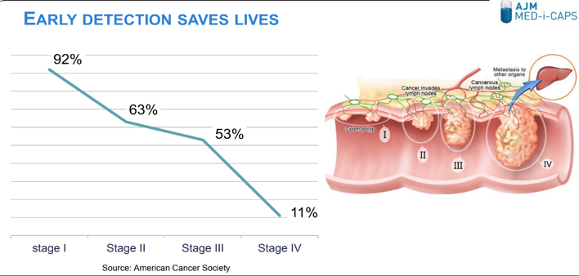

Figure 1- Five-year survival rate dependency on Stage of Cancer Detection

The current “gold standard” test for colon screening is colonoscopy, which remains a much-avoided procedure for the reasons identified in Figure 2, according to a study conducted by the Mayo Clinic.

48X’s solution to intestinal cancer screening aims to overcome the drawbacks of regular colonoscopy for large bowel cancer screening.

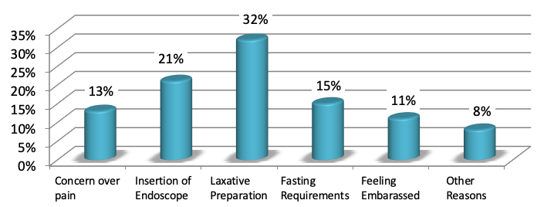

Figure 2- Reasons why people avoid colonoscopy as a CRC screening test

**Funding:**

48x Ltd started with the cofounders putting in the initial share capital. It then proceeded to win prizes from multiple startup competitions, including the MITEF Greece Startup Competition, where it won 1st place in 2018.

In 2020 it won a competitive ~€500K SEED grant from the Cyprus Research and Innovation Foundation. Finally, it has raised a further €2M SEED funding through a private investment round in 2022.

**Technology:**

In the last few years the company has been working on developing a revolutionary electronic pill which, in combination along with a proprietary precancer/cancer tracer will enable reliable and easy screening for polys (precancerous lesions), for both for the **small and the large** intestine. AJM has filed a **broad patent** in five geographical regions (WO2021038464, US20220370001, AU2020338422, JP2022546432, CN114521124, EP4021283), with thirty one claims, that **cover much more than the minimum viable product** (MVP) required for intestinal cancer screening. The patent claims cover an ingestible electronic fluorescence detection device in combination with the proprietary tracer that highlights abnormalities in the GI tract, with a **multitude of technical solutions** that make this device viable, e.g. methodology for eliminating the effect of variations in fluorescence levels due to distance from intestinal walls so as not to give false positives, features that enable long battery life etc. Furthermore, other features that are not in the MVP include taking a **high quality images of locations with high tracer levels** and also **targeted release or activation of drugs** at the location of the detected anomaly for **therapy**. It also includes **methods other than fluorescence** for detection, e.g. magnetic anomalies created by magnetic nanoparticles etc., so as to limit competitors freedom to operate by finding other tracer modalities. The pending patent is currently in the national phase and covers the USA, the European Union, China, Japan and Australia. The company **also relies on trade secrets** with aspects of the product that are **difficult to reverse engineer**. Given that the product will be made from custom Application Specific Integrated Circuits (ASICs), customised optical components, customised chemical tracers and custom software, it will be difficult for a competitor to copy it, without having to assemble an extremely specialised high-tech team, and even then they are likely to run into patent infringement issues.

To date the company has proven that the tracer accumulates in polyps in both genetically altered mice and genetically altered swine disease models.

|  |  |  |
| --- | --- | --- |
|  |  |  |
| *a) Image of two polyps in the foreground* | *b) Tracer concentrations accumulated in polyps* | *c) Overlay of tracer concentration in polyps* |
| Figure 4- Genetically-modified swine polyp models demonstrate the tracer accumulation | | |

Furthermore the company has proven that the capsule fluorometer subsystems have the necessary sensitivity to detect the tracer accumulating in the polyps and lesions. A route to low-cost, mass-production of the capsule has been established enabled by integrating the electronic and optical components on the same chip. This not only improves reliability but also reduces capsule assembly costs given fewer components are handled.

**Addressable Market**

“Opportunistic” CRC screening is somewhat ad hoc, whereby a patient or a general practitioner needs to take the initiative for CRC screening. In “Organized” screening a national program involves invitations to screen, and includes timely follow-up diagnostic tests, centralized database maintenance etc. The overall status of CRC screening in the Western hemisphere is depicted in Figure 6; the opportunistic nature of screening in several countries and the diversity of approaches & modalities employed in this growing market is a unique opportunity for a swift entry and extensive market capture, given that an accurate, cost-effective and pain-free screening test becomes available. In the US alone, where opportunistic primary colonoscopy is employed as the commonest screening option, 107 million Americans aged 50+ qualify for colonoscopy, and despite national and private TV campaigns, digital marketing, primary care sales force, collated materials, clinical & health publications, etc., almost 1 in 3 adults still do not engage with CRC screening; that equates to 28million Americans not having an up-to-date CRC check-up. The explanation is because of the reasons listed in Figure 2. In 2018 the American Cancer Society recommended that the screening should start at the age of 45 instead of 50 so the number non-engaged with screening is estimated to be around 50 million adults.

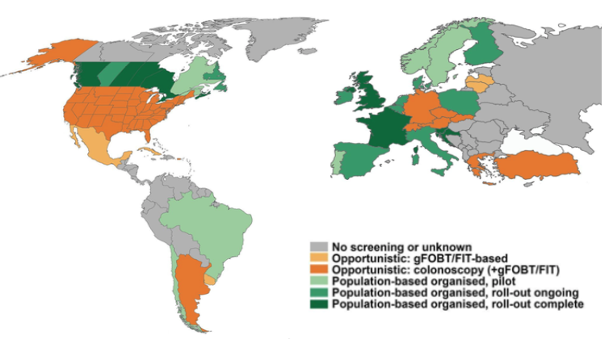

Figure 6- Global view of Opportunistic vs Organized CRC Screening

In the EU, in the larger countries ( UK, France, Spain Germany, Italy) the target population (aged 50-74) amounts to about 98 million. Currently only 3.5 million colonoscopies are done each year, meaning that there is much room for the penetration of an easy, accurate CRC screening test. Currently the EU is advancing with stool-based blood-detection test which has the drawback of late detection as explained earlier.

In Asia there is a sharp increase[1] in the incidence of colorectal cancer, possibly attributed to the economic growth and adoption of the western lifestyle. Lifestyle-related risk factors include smoking, alcohol, red- and processed meat consumption, obesity and physical inactivity.

Thus, due to the global threat of CRC (3rd most common cancer), the market is large. This resonates with the findings of an Industry ARC business report, which estimates the global colorectal cancer market size at $9.5Bn as of 2018, and projects the overall revenue avenues to increment at a compound annual growth rate (CAGR) of 2.60% during the forecast period of 2019 to 2025. The main competitors/commercially-available solutions have been addressed in section 1.2, where we presented the advantages of our product.

AJM’s market strategy will be to first penetrate the USA market and establish a first revenue stream, before moving on to follow on markets. The financial pain point is the highest in the USA for the medical insurance companies. The cost of CRC treatment is a few tens of thousands, on average, and an effective early stage and easy screening test can significantly reduce expensive claims. Furthermore, AJM will avoid the slow process of adoption of their product by the National Health Systems, that are prevalent in Europe. In the USA the population that is over 50 that would require screening amounts to 107million. Assuming that 90% of this population is covered by health insurance and narrowing the total addressable market (TAM) to people with a smartphone, etc, we estimate to be able to access about 10 million people per year, who are willing to take the CORE-SCREEN test, once every two years.

**Industry Description**

According to a survey, the **two most important characteristics** of an intestinal screening test for subjects are: 1) Reliable detection at an early stage and 2) A comfortable screening process. Currently there are a number of competing methods of screening, each with their pros and cons. **• Fecal specimen occult blood detection tests** are low cost, but also low accuracy. The FOB or FIT test will test positive if one has bleeding gums or an ulcer and also require the lesion to be at a stage where it bleeds. Furthermore, most people are uncomfortable with handling fecal matter; **Faecal specimen DNA test** (**Cologuard®)**, require that stools are collected and stirred within a solution before shipping by courier to a specialized laboratory in the USA. Despite improved accuracy for early cancer, compared FOB and FIT, it is costly and has low detection capacity for polyps; **• CT colonography** requires extensive bowel prep and only allows for morphological assessment of the bowel wall, often missing small lesions or the almost flat sessile serated adenomas (SSA). Furthermore there is always the risk of cumulative ionizing radiation to the screened individual; **• Check-Cap's (X-ray capsule)** is a pre-market product with a mini CT scanner in a pill and does not require bowel preparation. It has the same disadvantages as CT colonography with regards to small/flat lesions and also involves convincing subjects to swallow a pill with radioactive Osmium inside. Sensitivity for polyps was found to be 44% in clinical trials. The radioactive material becomes a problem once the capsule enters the sewage system after being expelled from the body; **• Colonic imaging capsule** (**PillCam®Colon2**) is a great non-invasive approach which requires a very clean intestine, thus requiring a very aggressive bowel preparation. Also the subject is required to wear an external belt/recorder for over a day to save the footage. A doctor is then required to look through hours of footage of the intestine, usually in an accelerated mode, trying to spot early stage lesions. This entails a high labor cost, that makes it unsuitable for a mass screening test; Lastly, the current undisputable reference standard for colonic screening, **the optical colonoscopy** is undoubtedly invasive and off-putting for the reasons shown in Figure2. To address the discomfort in most countries, this is performed under sedation or anesthesia, which comes with risks when screening the elderly. Moreover, the lack of colonoscopists and an unprecedented demand for regular screening has created a screening backlog.

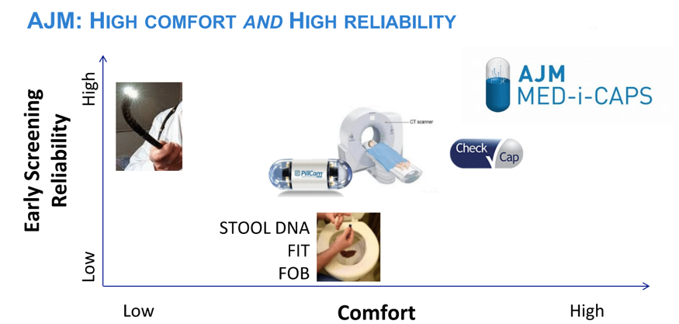

Figure 7- Comparing competition with the two most important characteristics to patients

Companies active in the intestinal cancer capsule screening field are:

* Given Imaging acquired by Medtronic
* Olympus
* Capsovision
* Intromedic
* Checkcap

Companies active in the fecal blood or fecal DNA tests are:

* Exact Sciences Corporation
* Fisher Healthcare
* Aerscher Diagnostics
* Cambridge Diagnostic Products
* Germain Laboratories
* Helena Laboratories

AJM Med-i-Caps future product will be in a category of its own given it combines the electronic pill technology with diagnostic nanoparticles to more accurately identify polyps/cancerous lesions in a more comfortable way.

1. Park S., Jee S.H. (2018) Epidemiology of Colorectal Cancer in Asia-Pacific Region. In: Kim N., Sugihara K., Liang JT. (eds) Surgical Treatment of Colorectal Cancer. Springer, Singapore